Wind Energy Assessment for Tower Data at 50 Meters

Maryclaire Okoro

Course: Wind Energy (MAE 579)

Professor: Ronald Calhoun

Date: September 12, 2024

# 1. Introduction

The purpose of this assignment is to assess the wind energy potential of a tower site using 50-meter height data. The wind speed and direction data were gathered using cup and vane anemometry. This data was analyzed to estimate the power yield from the Vestas V52/850 turbine at the site. The objective was to determine the feasibility of wind energy development at this location and classify the wind resource.

Key Performance Indicators (KPIs)

* Mean Wind Speed: 9.1217 m/s
* Standard Deviation of Wind Speed: 3.7125 m/s
* Estimated Total Energy Production: 3,897,338.565 kWh/year
* Wind Resource Class: Class 7 (Superb)

# 2. Data Collection and Methodology

## 2.1. Data Collection

The wind speed and direction data were collected over 12 months from a tower located in the Great Plains region of the United States, at a height of 50 meters. The dataset consists of 29,221 records with wind speeds ranging from 0.43 m/s (minimum) to 27.50 m/s (maximum). The Vestas V52/850 turbine power curve was obtained from Wind Energy Market Intelligence.

## 2.2. Methodology

Using MATLAB, the following analyses were performed:

1. Mean Wind Speed: Calculated to provide a general measure of wind strength at the site.

2. Standard Deviation of Wind Speed: Assessed to understand wind speed variability.

3. Wind Speed vs. Time Plot: A graph to visualize the temporal variation in wind speed.

4. Wind Direction vs. Time Plot: Showed how wind direction varied over the same period.

5. Wind Rose: Created using a polar histogram to show wind direction distribution.

6. Wind Speed Distribution: The Probability Density Function (PDF) was calculated to assess the frequency of different wind speeds.

7. Vestas V52 Power Curve:

* Used to estimate the turbine’s power output at varying wind speeds.
* The turbine's cut-in (3 m/s), rated (14 m/s), and cut-out (25 m/s) speeds were considered.

8. Energy Production Calculation:

* The wind speed PDF was multiplied by the turbine’s power output at each wind speed to estimate power production.
* The total energy produced over one year was calculated by integrating the power across all wind speeds and multiplying by the total hours in a year (8760 hours).

# 3. Results and Analysis

## 3.1. Estimated Total Energy Production

The total estimated energy production for the Vestas V52 turbine over one year is 3,897,338.565 kWh, based on the wind speed distribution and turbine power curve.

## 3.2. Wind Resource Class

With an average wind speed of 9.1217 m/s, the site falls into Wind Class 7 (Superb), which indicates an excellent wind resource suitable for commercial wind energy development.

## 3.3. Diurnal Wind Speed Patterns

The wind speed versus time plot revealed clear diurnal cycles, where wind speeds ranged between 5 m/s and 25 m/s over a 24-hour period. Typically, higher wind speeds occurred during the day, suggesting that the turbine would operate near its rated power output during these peak periods, significantly contributing to energy production.

## 3.4. Recommendation for Further Exploration

Given the high wind speeds, strong energy production potential, and regular diurnal patterns, further exploration and development of the site are strongly recommended.

# 4. Conclusion

This analysis has demonstrated that the site has excellent wind energy potential, with an average wind speed of 9.1217 m/s, which places it in Wind Class 7 (Superb). The estimated annual energy production of 3,897,338.565 kWh for the Vestas V52 turbine suggests that the site is highly promising for wind energy development. I will recommend proceeding with further feasibility studies, including technical assessments, financial modeling, and environmental impact evaluations, to assess the viability of constructing a wind farm at this location.

References

*Vestas V52/850 - Manufacturers and turbines - Online access*. (n.d.). The Wind Power. Retrieved September 12, 2024, from <https://www.thewindpower.net/turbine_en_27_vestas_v52-850.php>

|  |  |
| --- | --- |
| Figure 1: Wind Speed versus Time | Figure 2: Wind Direction versus Time |
| Figure 3: A Windrose | Figure 4: PDF of Wind Speed |

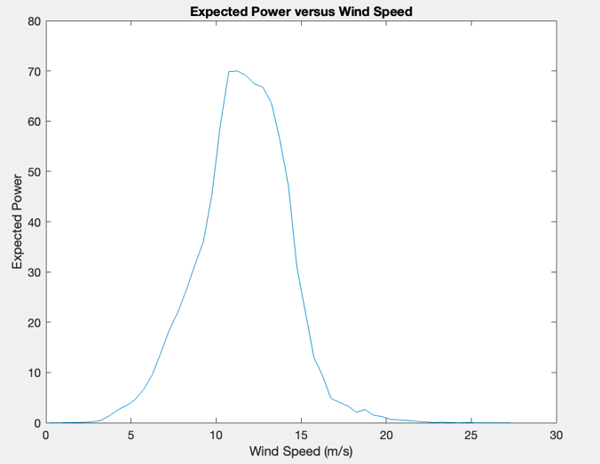

Figure 5: Expected Power versus Wind Speed